**Deployment of App in IBM Cloud**

**Containerize the App**

|  |  |
| --- | --- |
| Team ID | PNT2022TMID36311 |
| Project Name | Nutrition Assistant Application |

**Step – 1 :** Create the Dockerfile and paste the code

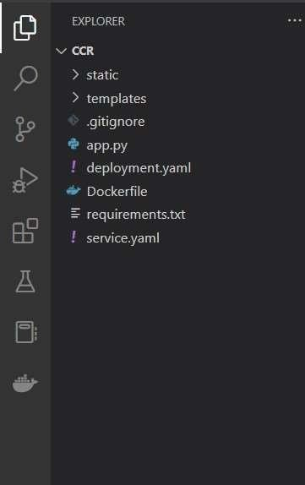

**Step - 2** : Build an image from the docker file.

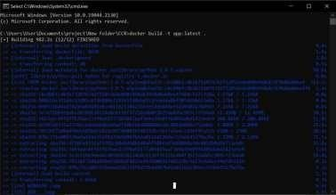

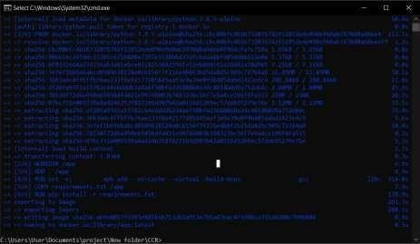

**Step - 3** : Run your container locally.

